**An Analysis of Locking and Overlapping in the context of**

**Augmented Reality on an Android Device**

Student Name: Dylan Tik Lun Chan

Programme Title: Bachelor of Science (Honours) in Computing with Games Development

Supervisors: Pat Doody and Robert Sheehy

Table of Contents

Abstract 4

Chapter 1: Introduction 4

Chapter 2: Augmented Reality 5

2.1 Introduction 5

2.2 Brief history of augmented reality 5

2.2.1 First Augmented Reality (HMD) 5

2.2.2 Videoplace 6

2.2.3 AR Powered User Manual 6

2.2.4 ARToolKit 6

2.3 Augmented Reality on Smartphones 7

2.3.1 Android OS 7

2.3.2 iOS 7

2.3.3 ARKit 7

2.3.4 ARCore 7

2.4 Challenges with Augmented Reality on Smartphones 8

2.4.1 Battery Consumption 8

2.4.1 Camera Quality 8

2.4.2 Network Dependency 8

2.5 Challenges AR faced both in development and social acceptance 8

2.5.1 Development Challenges 8

2.5.2 Social Acceptance Challenges 9

2.6 Augmented Reality in Other fields 9

2.6.1 Augmented Reality in Gaming 9

2.6.2 Augmented Reality in Education 10

2.6.3 Augmented Reality in Media & Advertisement 10

2.6.4 Augmented Reality in Healthcare 11

2.7 The Differences between Augmented Reality and Virtual Reality 12

2.8. Simultaneous Localization and Mapping (SLAM) 12

2.9 Types of Augmented Reality 13

2.9.1 Marker-Based AR 13

2.9.2 Marker-less AR 14

2.9.3 Superimposition Based AR 14

2.9.4 Projection Based AR 15

2.10 The Main Components to Augmented Reality Devices 15

2.10.1 Sensors and Cameras 15

2.10.2 Projection 16

2.10.3 Processing 16

2.10.4 Reflection 16

Chapter 3. Augmented Reality Environment Technologies 17

3.1 AR Technologies 17

3.1.1 Vuforia AR 17

3.1.2 Vuforia User Defined Targets 17

3.1.3 Vuforia Ground Plane 17

3.1.4 Vuforia Image Targets 17

3.1.5 Use of Vuforia 18

3.1.5 Kudan AR SDK 18

3.2 Unity 3D Game Engine 18

3.3 GitHub Version Control 18

Chapter 4: Methodology & Design 19

4.1 Key Findings 19

4.2 Research Question 19

4.3 Project Proposal 19

4.4 System Design 20

4.4.1 Vision Document 20

Chapter 5: Implementation 26

5.1 Sprint 1 26

5.2 Sprint 2 28

Vuforia Image Target Experiment: 29

Vuforia User Defined Targets Experiment: 32

Vuforia Ground Plane Experiment 37

5.3 Sprint 3 39

**References** 44

# Abstract

Augmented Reality (AR) allows the user to display virtual objects to the real world environment. Augmented Reality technology has been around for a long time, but AR in recent years has started becoming a trend in technology because of more advanced smartphones that have the capabilities to handle new and improved AR techniques. There is a few AR techniques such as marker-based AR, marker-less AR and superimposition based AR. Marker-based AR is the use of an image as a location for virtual objects to appear on screen. Marker less AR does not require the use of an image as a location for virtual objects instead collects images over the internet and displayed on any specific location.

The objective of this investigation was to analysis locking and overlapping in Augmented Reality (AR) using marker-based and marker less AR technique. This was accomplished using Unity 3D game engine and Vuforia software development kit (SDK). Vuforia have different types of marker based techniques. This investigation analyzed Vuforia Image Target, Vuforia User Defined Targets and Vuforia Ground Plane. Experiments was setup to tests locking of Vuforia Image Target, Vuforia User Defined Targets and Vuforia Ground Plane. An AR chessboard was made and AR chess pieces was made which overlaps the chessboard.

Overall,

# Chapter 1: Introduction

//Leave until the end

# Chapter 2: Augmented Reality

## 2.1 Introduction

Augmented reality (AR) is a technology that allows the user to display virtual content to the real world environment (Cushnan & El Habbak, 2013), whether it be images, audio, video and haptic touch (Kipper & Rampolla, 2012).Augmented reality technology commonly can be seen implemented using a mobile devices to display virtual content to the real world. AR has been used for decades but it can also be considered a new promising technology, it is only recently that it reached the mainstream. (Cushnan & El Habbak, 2013).According to Greg Kipper and Joseph Rampolla”Augmented Reality can be thought of as the blend, or the “middle ground,” between the completely synthetic and the completely real. ” (Kipper & Rampolla, 2012).

## 2.2 Brief history of augmented reality

### 2.2.1 First Augmented Reality (HMD)

In 1968, the first augmented reality prototypes was created by Ivan Sutherland a computer graphics pioneer and his students at Harvard University and the University of Utah used a see-through to view 3D graphic(Fig2.1) (van Krevelen & Poelman, 2010).

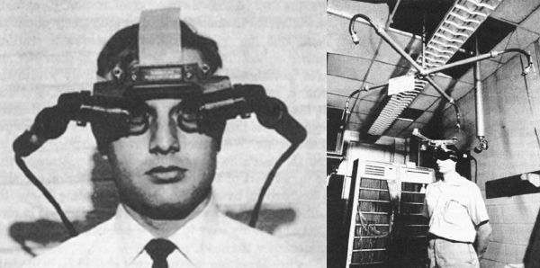

Fig2.1 The first augmented reality head-mounted display (Shore, 2012)

### 2.2.2 Videoplace

In 1975, Myron Krueger (Kipper & Rampolla, 2012) for the first time created ‘Videoplace’ a laboratory that consist of projectors and cameras which allowed users to interact with virtual objects (Fig 2.2) (Matthew, 2017).

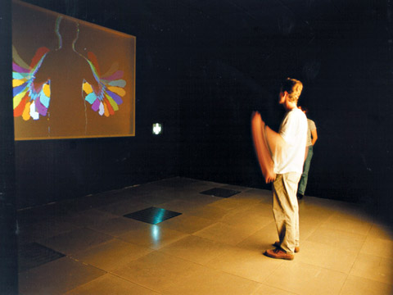

Fig 2.2 Videoplace (Matthew, 2017)

### 2.2.3 AR Powered User Manual

In 1990 Tom Caudell, a researcher in Boeing created an AR powered user manual for the electrical diagrams of flights and replaced the traditional diagrams on a plywood board (Matthew, 2017).

### 2.2.4 ARToolKit

In 1999, Hirokazu Kato, a professor from Osaka University (Matthew, 2017) created and released the ARToolKit to the open source community (Kipper & Rampolla, 2012). The ARToolKit allows for video capture in the real world environment to be combined with virtual objects. This AR kit can be run on any operating system (Kipper & Rampolla, 2012). Currently most of the Flash-based AR that is seen on web browsers uses the ARToolKit (Kipper & Rampolla, 2012).

## 2.3 Augmented Reality on Smartphones

Many smartphone devices such Android and iOS devices has become so sophisticated and powerful in terms of computing and context sensing infrastructure. With many people now a days owning a smartphones, the interaction between the user and augmented reality has allowed this technology to gain attention. Through the smartphone device, the camera allows the user to experience augmented reality with virtual content on their smartphone devices. Currently there are many augmented reality apps available through the iOS app store and Google Play app store (Kim, et al., 2014).

### 2.3.1 Android OS

In 2003, Android Inc. was established by Andy Rubin, Rich Miner, Nick Sears and Chris White. They first focused on implementing Android into digital camera devices. However they later focused on implementing Android on mobile phones. The team developed an operating system for mobile devices which could be aware of both user’s location and their personal preferences. In 2005, Android Inc. was acquired by Google and In October 2008. The first Android OS device was released to the public, the HTC Dream (Brachmann, 2014).

### 2.3.2 iOS

iOS is a mobile operating system developed by Apple Inc. Apple released iOS formerly called iPhone OS on June 29, 2007 (Orf, 2016).

### 2.3.3 ARKit

ARKit is Apple’s own augmented reality (AR) software tools that enables developers build AR applications for iOS. Currently any apple devices that runs on Apple’s A9, A10 or A11 Bionic Processors supports ARKit. The ARKit utilises iPhone and iPad hardware, they include motion-tracking a sensors and camera sensors (McGarry, 2018).

### 2.3.4 ARCore

ARCore is Google’s own augmented reality (AR) software tool that enables developers to build AR applications on Android mobile devices. It currently supports limited Android phones running Android 7.0 and later. ARCore utilises three key technologies: Motion tracking, environment understanding and light estimation (Google, 2017).

## 2.4 Challenges with Augmented Reality on Smartphones

### 2.4.1 Battery Consumption

Camera sensory on smartphones requires a lot of battery especially when it needs to be constantly running at high frame rates. A smartphone running an AR application can deplete the battery really fast as it is constantly running the camera sensory (Clemens & Dieter Schmalstieg, 2011).

### 2.4.1 Camera Quality

Camera Quality is very important for AR applications to run smoothly, a lot of smartphones cameras in recent years have improved, but some smartphone cameras still suffer from low lighting conditions, this will cause images to become blurry and the colours starts to suffer because it (Clemens & Dieter Schmalstieg, 2011).

### 2.4.2 Network Dependency

Remotely accessing large amount of data can result several implications. If data has to be accessed remotely this can cause lags on the instant behaviour of AR applications. Assessing data remotely also requires network connection, network coverage may not be always available, even if available it may be slow and lastly network connection also requires data plans that can be expensive (Clemens & Dieter Schmalstieg, 2011).

## 2.5 Challenges AR faced both in development and social acceptance

### 2.5.1 Development Challenges

During the early years of augmented reality, in order to use AR application the user had to use a computer and a Head Mounted Display (HMD). During the early years of augmented reality, there was a lack of hardware technology and IT infrastructure that could allow users to fully experience AR. HMD caused inconvenience for the user as the device can interrupt the user’s view of vision. There are more specialised hardware available other than using smartphones such as the Google glasses. The price of the Google glasses is too expensive for a regular consumer. Another challenge is that the current Google glasses cannot be used by a user who requires normal glasses (Kim, et al., 2014).

One of augmented realities most significant technical challenge is object recognition and sensor accuracy. “Objects in the real and virtual world must be properly aligned with respect to each other, or the illusion that the two worlds coexist will be affected, sometimes severely.” “Sensory accuracy applies to mobile AR and the systems that support it” (Kipper & Rampolla, 2012). Many current smart mobile augmented reality devices use one or more of the following tracking technologies: digital cameras and or other types of optical sensors, GPS, gyroscopes, accelerometers, radio-frequency identification (RFID) and wireless sensors. Other challenges augmented reality faces is when handling location-based AR with indoor positioning and line-of-sight. Additionally, many mobile devices have small screen sizes which may affect user experience with AR. There are products like Apple’s iPads and other manufactures tablets that have larger screen sizes that can allow the user to have a richer experience (Kipper & Rampolla, 2012).

### 2.5.2 Social Acceptance Challenges

The final challenge that augmented reality must face is social acceptance. Many people have become accustomed to augmented reality because of entertainment such as movies and television which has used images of simulated AR. Getting or convincing people to wear a augmented reality device can be quite a challenge as they may feel awkward wearing such a device around public. There are also privacy issues that people may be concerned about such as using an augmented reality device to track and record. These issues must be addressed before augmented reality can be fully accepted by the public (Azuma, et al., 2001).

## 2.6 Augmented Reality in Other fields

### 2.6.1 Augmented Reality in Gaming

Pokémon Go (Fig 2.5) released in 2016, was one of the first games to implement geo-located augmented reality elements and It became the most popular game in the history of smartphone games. Over 100 million users from 30 countries downloaded the game (Zsila, 2017).The main goal of Pokémon Go is to capture all Pokémon and to level up as well as to improve their Pokémon stats (Zsila, 2017). Pokémon Go integrates many new areas in computer technology such as a mobile device’s GPS and a camera, real time database interaction, computations, etc. The game uses the user’s geographical location and by moving around in real world environment, the player can find and capture different Pokémon. It also uses geographical location to determine which type of Pokémon will spawn, for example, only some water type Pokémon will appear when you are near water locations (Huang , 2016).

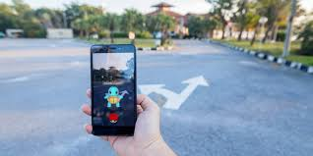

Fig 2.5 Pokémon Go (Mix, 2017)

### 2.6.2 Augmented Reality in Education

One use of augmented reality in education is the use of AR textbooks. The textbooks are just like a normal printed textbooks. What makes it into augmented reality is just by pointing a webcam to the textbooks, this will bring augmented visual and interactive experience to the reader. This technology can also be used by using a smartphone camera and installing a special mobile app (Kesim & Ozarslan, 2012).

### 2.6.3 Augmented Reality in Media & Advertisement

Media & Advertisement, IKEA a swish company that designs and sells ready to assemble furniture, kitchen appliances and home accessories (Loeb, 2013). In September 2017, IKEA lunched their own AR app. The AR app allows customers to visualize what their furniture might look like in their own living rooms, kitchen and bedrooms etc. (Lee, 2017). It allows user to reposition the furniture and the user can move closer or further away from them to view the furniture from different perspective, this allows the user to have a 360 degree view of an furniture (Fig 2.6 & 2.7) (Bell, 2017).

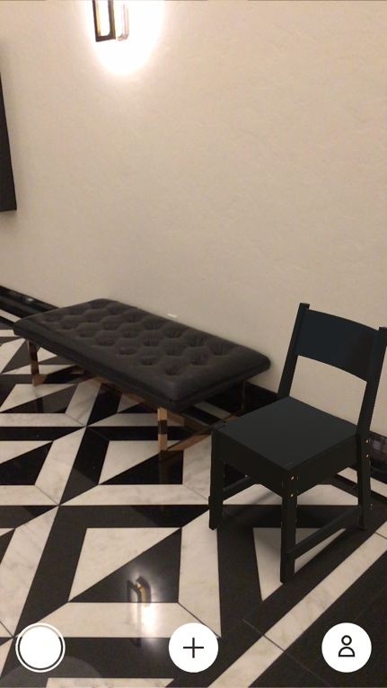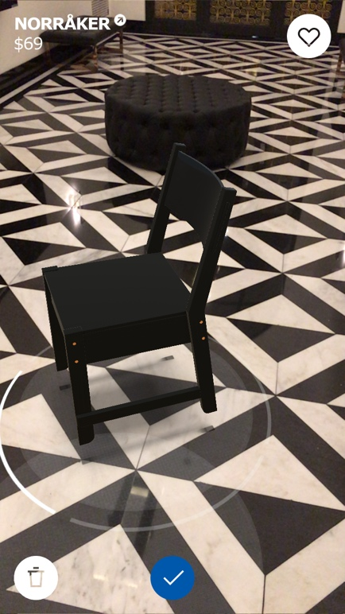  
 Fig 2.6 (Bell, 2017) Fig 2.7 (Bell, 2017)

### 2.6.4 Augmented Reality in Healthcare

An article published by Frontier in Neuroscience about helping amputee with phantom limb pain using augmented reality. They investigated a treatment in which the virtual limb responds directly to myoelectric activity at the stump, while the illusion of a restored limb is enhanced through AR. The proposed set of technologies was used to try help chronic phantom Limb pain patient who has shown resistance to a variety of treatment for their chronic phantom limb pain for 48 years (Ortiz-Catalan, et al., 2014). Individual and simultaneous phantom movements were predicted using myoelectric pattern recognition and were then used as input for VR and AR environments (Ortiz-Catalan, et al., 2014). The patient also wore AR headset that would superimpose his missing limb. The treatment were found to be effective why of alleviating the phantom limb pain from the patients after 10 weeks of session, patients reported episode of absent pain started occurring and this then developed into completely pain-free periods a few more sessions later (Ortiz-Catalan, et al., 2014).

## 2.7 The Differences between Augmented Reality and Virtual Reality

Augmented reality and Virtual Reality are distinct technologies even though they share some common technology. Virtual Reality (VR) is a completely artificial digital environment that uses computer hardware and software to generate and simulate a real world environment to the user. For a user to have a immersive experience they must first put on special equipment such as special gloves, earphones, and googles, all of which receive their input from the computer system(Fig 2.7). Virtual Reality is full immersion into a simulated world while augmented reality is displaying digital information to a real-world environment. In the end the biggest difference between the two more than anything else is that VR takes place in the real world and AR does not (Kipper & Rampolla, 2012)

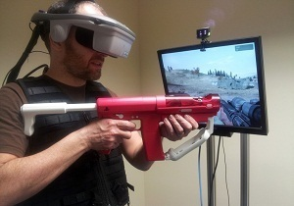

Fig 2.7 Virtual Reality (VR) (Orland, 2012)

## 2.8. Simultaneous Localization and Mapping (SLAM)

Early research of Simultaneous Localization and Mapping (SLAM) technique was focused on how to achieve autonomous control of robots in a robotics review paper by (Taketomi, et al., 2017) which was in (Chatila & Laumond, 1985).SLAM technique provides accurate tracking in unknown and new environments. SLAM refers set of algorithms trying to figure out the pose (position and orientation) estimation and 3D mapping problem simultaneously while a device is moving through the environment (Reitmayr, et al., 2010). Visual SLAM (VSLAM) can be implemented into augmented reality. VSLAM is as stated by Osian Haines “where the primary mode of sensing is via a camera” (Haines, 2016). Marker based AR technology is not SLAM, because the marker based AR image is already known in advance. SLAM must operate in real time, by real-time it means that incoming camera image must be processed by the time a new camera image arrives, by doing this technique the pose of the camera is available immediately, not at the post processing stage. Unlike structure from motion (SfM) technique a stated by Osian Haines “where a set of unordered images are processed offline to recover the 3D structure of an environment” (Haines, 2016). This type technique can be time consuming (Haines, 2016),

## 2.9 Types of Augmented Reality

Marker-based and marker-less AR are two simple types of augmented reality available. Marker- based AR uses a technique that embeds a 3D virtual model into a physical object (Kipper & Rampolla, 2012). Marker-less AR uses positional data such as GPS location of a smartphone (Katiyar, et al., 2015).

### 2.9.1 Marker-Based AR

Maker-based AR uses images that can be detected by a camera and incorporates with a software as the location for a virtual assets to appear on screen. The image is usually black and white (Fig 2.8), however colours can be used as long as the camera can recognizes the contrast between the different colours on the image (Katiyar, et al., 2015). Marker-based AR implementation is ideal for if your environment is fixed or your virtual space does not go beyond the marker-based AR card. (Ufkes & Fiala, 2013)



Fig 2.8 An Example of a marker based AR card (Danny, 2013)

### 2.9.2 Marker-less AR

Maker-less AR collects images from the internet and displayed on any specific location. The data can be gathered by using GPS location. Unlike maker-based applications AR, this does not require any maker to display the virtual assets on screen, this makes maker-less AR application more interactive than marker-based AR applications (Katiyar, et al., 2015)

### 2.9.3 Superimposition Based AR

Superimposition based AR either partially or fully replaces the original view of an object with a newly augmented view of that same object (Fig 2.9) (Reality Technologies, 2016).

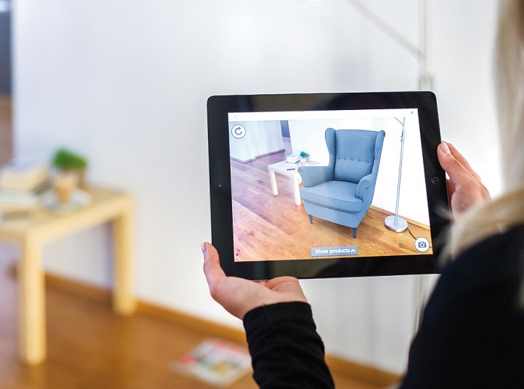

Fig 2.9 Superimposition Based AR (Reality Technologies, 2016)

### 2.9.4 Projection Based AR

Projection based AR is the use of projection technology to augment and enhance 3D objects and spaces in the real world by projecting images onto their visible surfaces (Fig 2.10) (Mine, et al., 2012).

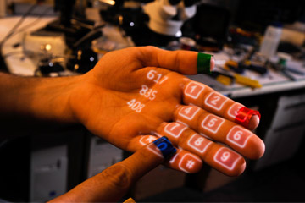

Fig 2.10 Projection Based AR (Reality Technologies, 2016)

## 2.10 The Main Components to Augmented Reality Devices

The main components to Augmented Reality (AR) Devices are sensors, cameras, projection, processing and reflection.

### 2.10.1 Sensors and Cameras

Sensors are typically located outside of the AR device, they are used to gather user’s real world interactions and communicate them to be processed and interpreted. Cameras are also typically located outside the AR device, they are responsible for visually scanning and collect data about the real world environment. The AR devices take this information and data, it then determines where surrounding physical objects are located (Reality Technologies, 2016)

### 2.10.2 Projection

Projection is a miniature projector often found in a forward and outward-facing position on a wearable AR devices. The projector can turn any surface into an interactive environment in the real-world. The information that is taken by the camera and processed is projected onto the surface in front the user who is wearing the AR device (Reality Technologies, 2016).

### 2.10.3 Processing

The processing components that are in an AR devices can include a CPU, a GPU, flash memory, RAM, Bluetooth, WIFI microchip, GPS microchip, and many more. More advanced AR devices like the Microsoft HoloLens (mixed reality) uses an accelerometer, gyroscope and magnetometer to give users true immersive experience (Reality Technologies, 2016).

### 2.10.4 Reflection

AR devices uses mirrors to help with the way our eye views the virtual object/image. Some of the AR devices uses “an array of many small curved mirrors” and others may use simple double-sided mirror with one surface reflecting incoming light to a side-mounted camera and the other surface reflecting light from a side-mounted display to the user’s eye (Reality Technologies, 2016).

# Chapter 3. Augmented Reality Environment Technologies

## 3.1 AR Technologies

### 3.1.1 Vuforia AR

Vuforia is an augmented reality SDK (software development kit) developed by Qualcomm. It has one of the fastest tracking algorithms available today in the market that is less prone to trackable occlusion and low light conditions. Vuforia is also available for free, but the free version will have a Vuforia watermark on the AR software application. As it is one of the best AR SDK available currently, there is a lot of help and guides available on the internet (Cushnan & El Habbak, 2013). Vuforia make use of the computer vision technology to recognize and track graphic images and 3D objects in real time (Peng & Jing , 2017). As of 2017 Vuforia is now built into Unity 3D 2017, Developers’ no longer have to download a Vuforia SDK from their website and import it to Unity.

### 3.1.2 Vuforia User Defined Targets

User-defined targets are Image Targets that are created at runtime from camera frames selected by the user. The user can select an image in the environment, for example like a magazine cover, poster and photos etc. without ever having to pre define which image the AR object has to be which is the traditional way of marker based AR (Vuforia , 2012).

### 3.1.3 Vuforia Ground Plane

Vuforia Ground Plane is a new feature introduced in Vuforia 7 and only available in Unity version 2017.3. Ground Plane enables virtual objects to be placed on horizontal surfaces, examples are floors and on flat surface of a table. Virtual objects can also be placed mid- air using anchor points. (Vuforia, 2018)

### 3.1.4 Vuforia Image Targets

Vuforia Image Targets allows the Vuforia SDK to detect and track image targets without the use of QR Codes that you would have traditionally, because with Vuforia Image Targets it does not need the black and white colours to detect and track because the image target is stored in a database known as the target resource database. Once Vuforia SDK have detected the Image Target it will keep tracking image as long as it is still in the view of the camera’s field of view eve if it’s not fully on the camera’s field of view it can still track the image (Vuforia , 2015).

### 3.1.5 Use of Vuforia

Vuforia AR is currently is being used in education, instructional, gaming. In Education, Vuforia can be used in museums, the visitors of museum can be see information about the artist or see the unseen in the artwork in an augmented reality way. (Ibanez & Figueras, 2013)

One use of Vuforia in Instructional field is a step by step guide or troubleshooting a product. This type of feature can used with assembling a product, the instructions on how to assemble the product would be in an augmented way. (Ibanez & Figueras, 2013)

In gaming Vuforia is used a lot by developers to develop augmented reality games such as puzzle AR games, strategy AR games etc. (Ibanez & Figueras, 2013)

### 3.1.5 Kudan AR SDK

Kudan is a UK-Japanese company founded in 2011 at Bristol, England (Kudan, n.d.). Kudan AR SDK can support both either marker or maker less tracking and location requirements. It can be ported into any platforms with any peripherals (Kudan, n.d.). Kudan is available for free, but the free version will have a Kudan watermark on the AR software application.

## 3.2 Unity 3D Game Engine

Unity is a cross-platform game engine that is developed by Unity Technologies. Unity has its own IDE (Integrated development environment) built in called Monodevelop. It is the most popular game engine and a free version is available for download. Unity can be deployed on Windows, Mac OS, iOS, Android, web plugins, flash, Microsoft’s Xbox One and Sony’s PlayStation 4 and Nintendo Switch. Unity allows user to use C#, JavaScript or Boo to write your scripts (Cushnan & El Habbak, 2013). Kudan AR SDK and Vuforia AR SDK can be used with Unity for Augmented Reality development.

## 3.3 GitHub Version Control

In 2008, GitHub went live, it is one of the most popular used for version control. GitHub is a free and open-source software based on Git, a version control system (Davis , 2015). By using GitHub software developers can upload their projects to GitHub and keep track of changes to their projects. GitHub allows collaborations between developers in a project very easy and efficient.

# Chapter 4: Methodology & Design

## 4.1 Key Findings

In Augmented Reality there are two main types of AR one is the marker based AR technology and the second, would be maker less AR technology. Even though augmented reality technology has been around for a long time, it is only recently that the AR technology started to show its full potential, with many modern smartphones now capable of supporting augmented reality technology. In Augmented Reality, locking is a very important that a smartphone camera or any other type of camera that is doing locking in AR is able to lock onto a virtual object and maintain that lock throughout and be able to relock onto the virtual object after moving the camera away from the virtual object and back at it again.

## 4.2 Research Question

This research is focused on locking and overlapping in augmented reality.

1. Use marker less augmented reality (Vuforia Ground Plane)
2. Use of maker based augmented reality.
3. Combine these features into one.

## 4.3 Project Proposal

This project will be Augmented Reality game project. An augmented reality game will be developed with Unity 3D game engine and it will be developed for an android smartphone device. There will also be experiments on locking and overlapping using Vuforia AR technology on how well it performs using an Android device.

## 4.4 System Design

### 4.4.1 Vision Document

**MoSCoW method:**

**M** = **Must** Have

**S** = **Should** Have

**C** = **Could** Have

**W** = **Won’t** Have

|  |  |  |
| --- | --- | --- |
| 001 | Marker Based AR | Must Have |
| 002 | Multiplayer | Won’t Have |
| 003 | Marker less AR | Must Have |

#### 4.4.2 Prototypes

##### 4.4.2.1 Vuforia Maker based AR Tutorial sample (Web Camera)

|  |  |  |
| --- | --- | --- |
| **Prototype** | **Start Date** | **Finish Date** |
| 1 | 23/09/2017 | 24/09/2017 |

|  |  |  |
| --- | --- | --- |
| **Task Number** | **Details** | **Status** |
| 1 | Download and install Unity 3D and Visual Studio 2013 | Complete |
| 2 | Download Vuforia SDK for Unity 3D  Import Vuforia SDK into Unity 3D | Complete |
| 3 | Create a Vuforia account | Complete |
| 4 | Tutorial on Vuforia Marker based AR  Tutorial link: <https://www.youtube.com/watch?v=oC9k5Yd4020> | Complete |
| 5 | Test Vuforia Marker based AR | Complete |

##### 4.4.2.1 Spaceship Marker less AR (Without any AR SDKs)

|  |  |  |
| --- | --- | --- |
| **Prototype** | **Start Date** | **Finish Date** |
| 2 | 25/10/2017 | 29/10/2017 |

|  |  |  |
| --- | --- | --- |
| **Task Number** | **Details** | **Status** |
| 1 | Download and install Unity 3D and Visual Studio 2013 | Complete |
| 2 | Download and install Android Studio and configure it correctly. | Complete |
| 3 | Tutorials on Marker less AR without AR SDKs  Tutorial Link:  <https://www.youtube.com/watch?v=T6bd_MQ2ass> | Complete |
| 4 | Connect a suitable Android device to laptop  Build and run the application in Unity 3D | Complete |
| 5 | Test Marker less AR Spaceship Game | Complete |

##### 4.4.2.3 Vuforia AR Marker based Android Tutorial sample

|  |  |  |
| --- | --- | --- |
| **Prototype** | **Start Date** | **Finish Date** |
| 3 | 30/11/2017 | 30/11/2017 |

|  |  |  |
| --- | --- | --- |
| **Task Number** | **Details** | **Status** |
| 1 | Download and install Unity 3D and Visual Studio 2013 | Complete |
| 2 | Download and install Android Studio and configure it correctly. | Complete |
| 3 | Create a Vuforia account | Complete |
| 4 | Tutorials on Vuforia Android Marker based AR  Tutorial Link: <https://www.youtube.com/watch?v=HnjbTytHH6U&ab_channel=Vergium> | Complete |
| 5 | Connect a suitable Android device to connect to laptop  Build and run the application in Unity 3D | Complete |
| 6 | Test Vuforia Android Marker based AR | Complete |

##### 4.4.2.4 Vuforia AR Marker based User defined targets Android Tutorial sample

|  |  |  |
| --- | --- | --- |
| **Prototype** | **Start Date** | **Finish Date** |
| 4 | 03/12/2017 | 04/12/2017 |

|  |  |  |
| --- | --- | --- |
| **Task Number** | **Details** | **Status** |
| 1 | Download and install Unity 3D, import the sample package from Unity asset store. | Complete |
| 2 | Download and install Android Studio and configure it correctly. | Complete |
| 3 | Create a Vuforia account | Complete |
| 4 | The link to the sample [https://www.assetstore.unity3d.com/en/#!/content/99026](https://www.assetstore.unity3d.com/en/%23!/content/99026) | Complete |
| 5 | Connect a suitable Android device to connect to laptop  Build and run the Sample in Unity 3D | Complete |
| 6 | Test Vuforia User defined targets | Complete |

##### 4.4.2.5 Prototype Screenshots

Vuforia User Defined Targets

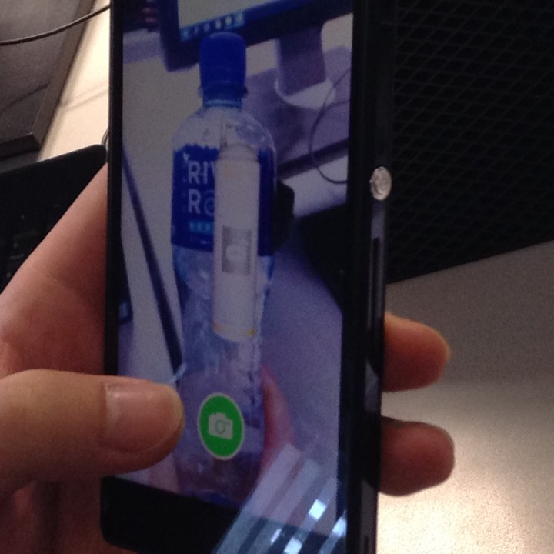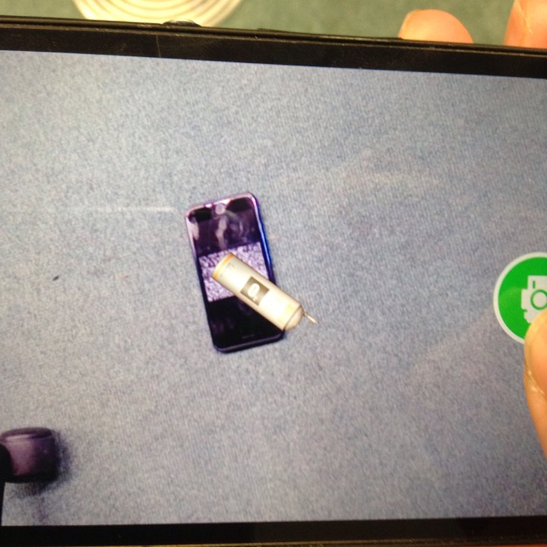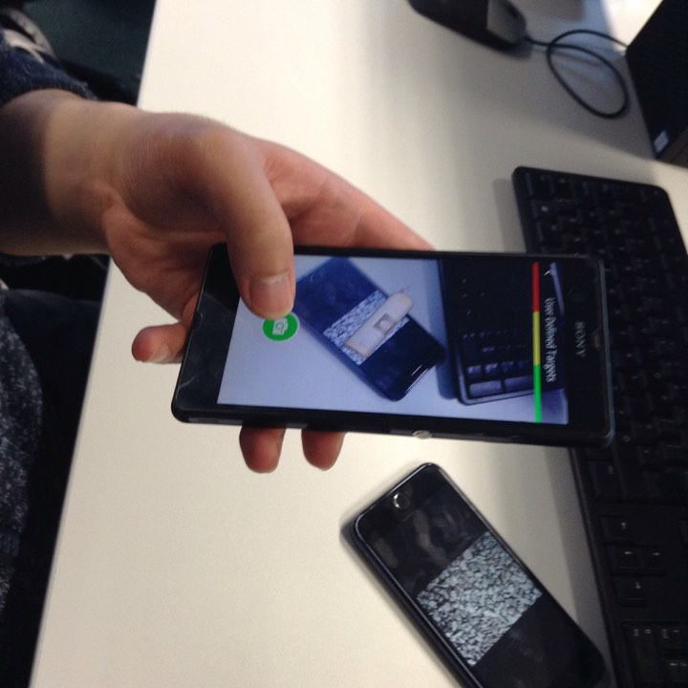

Vuforia Marker Based (Not with User defined targets)

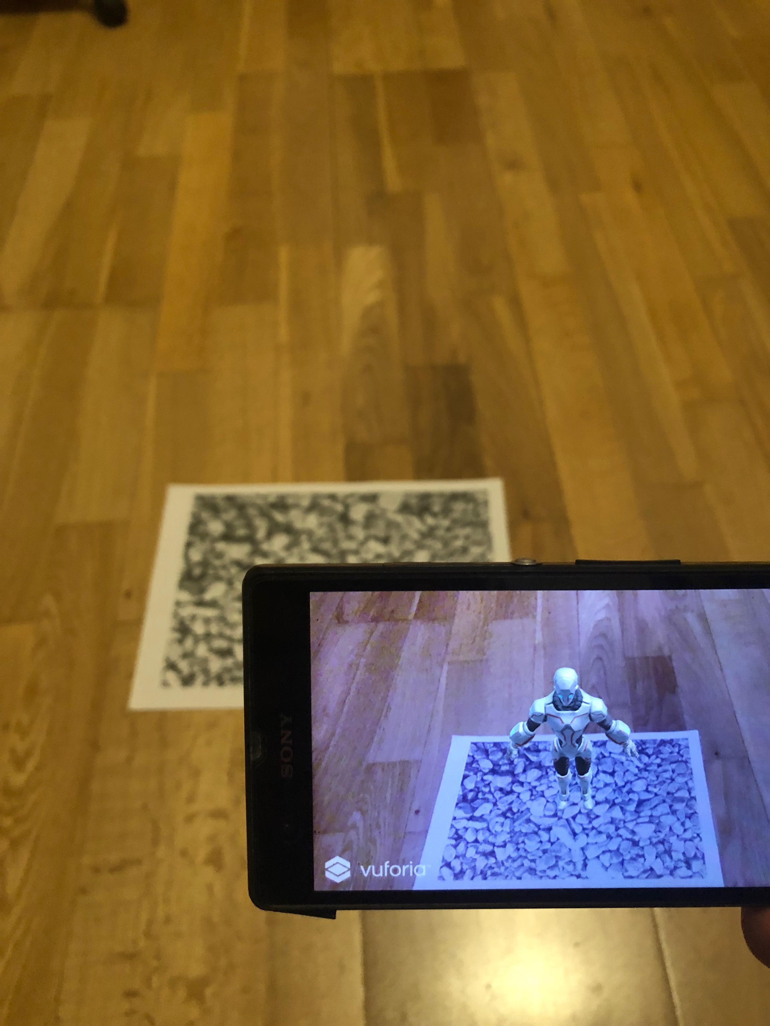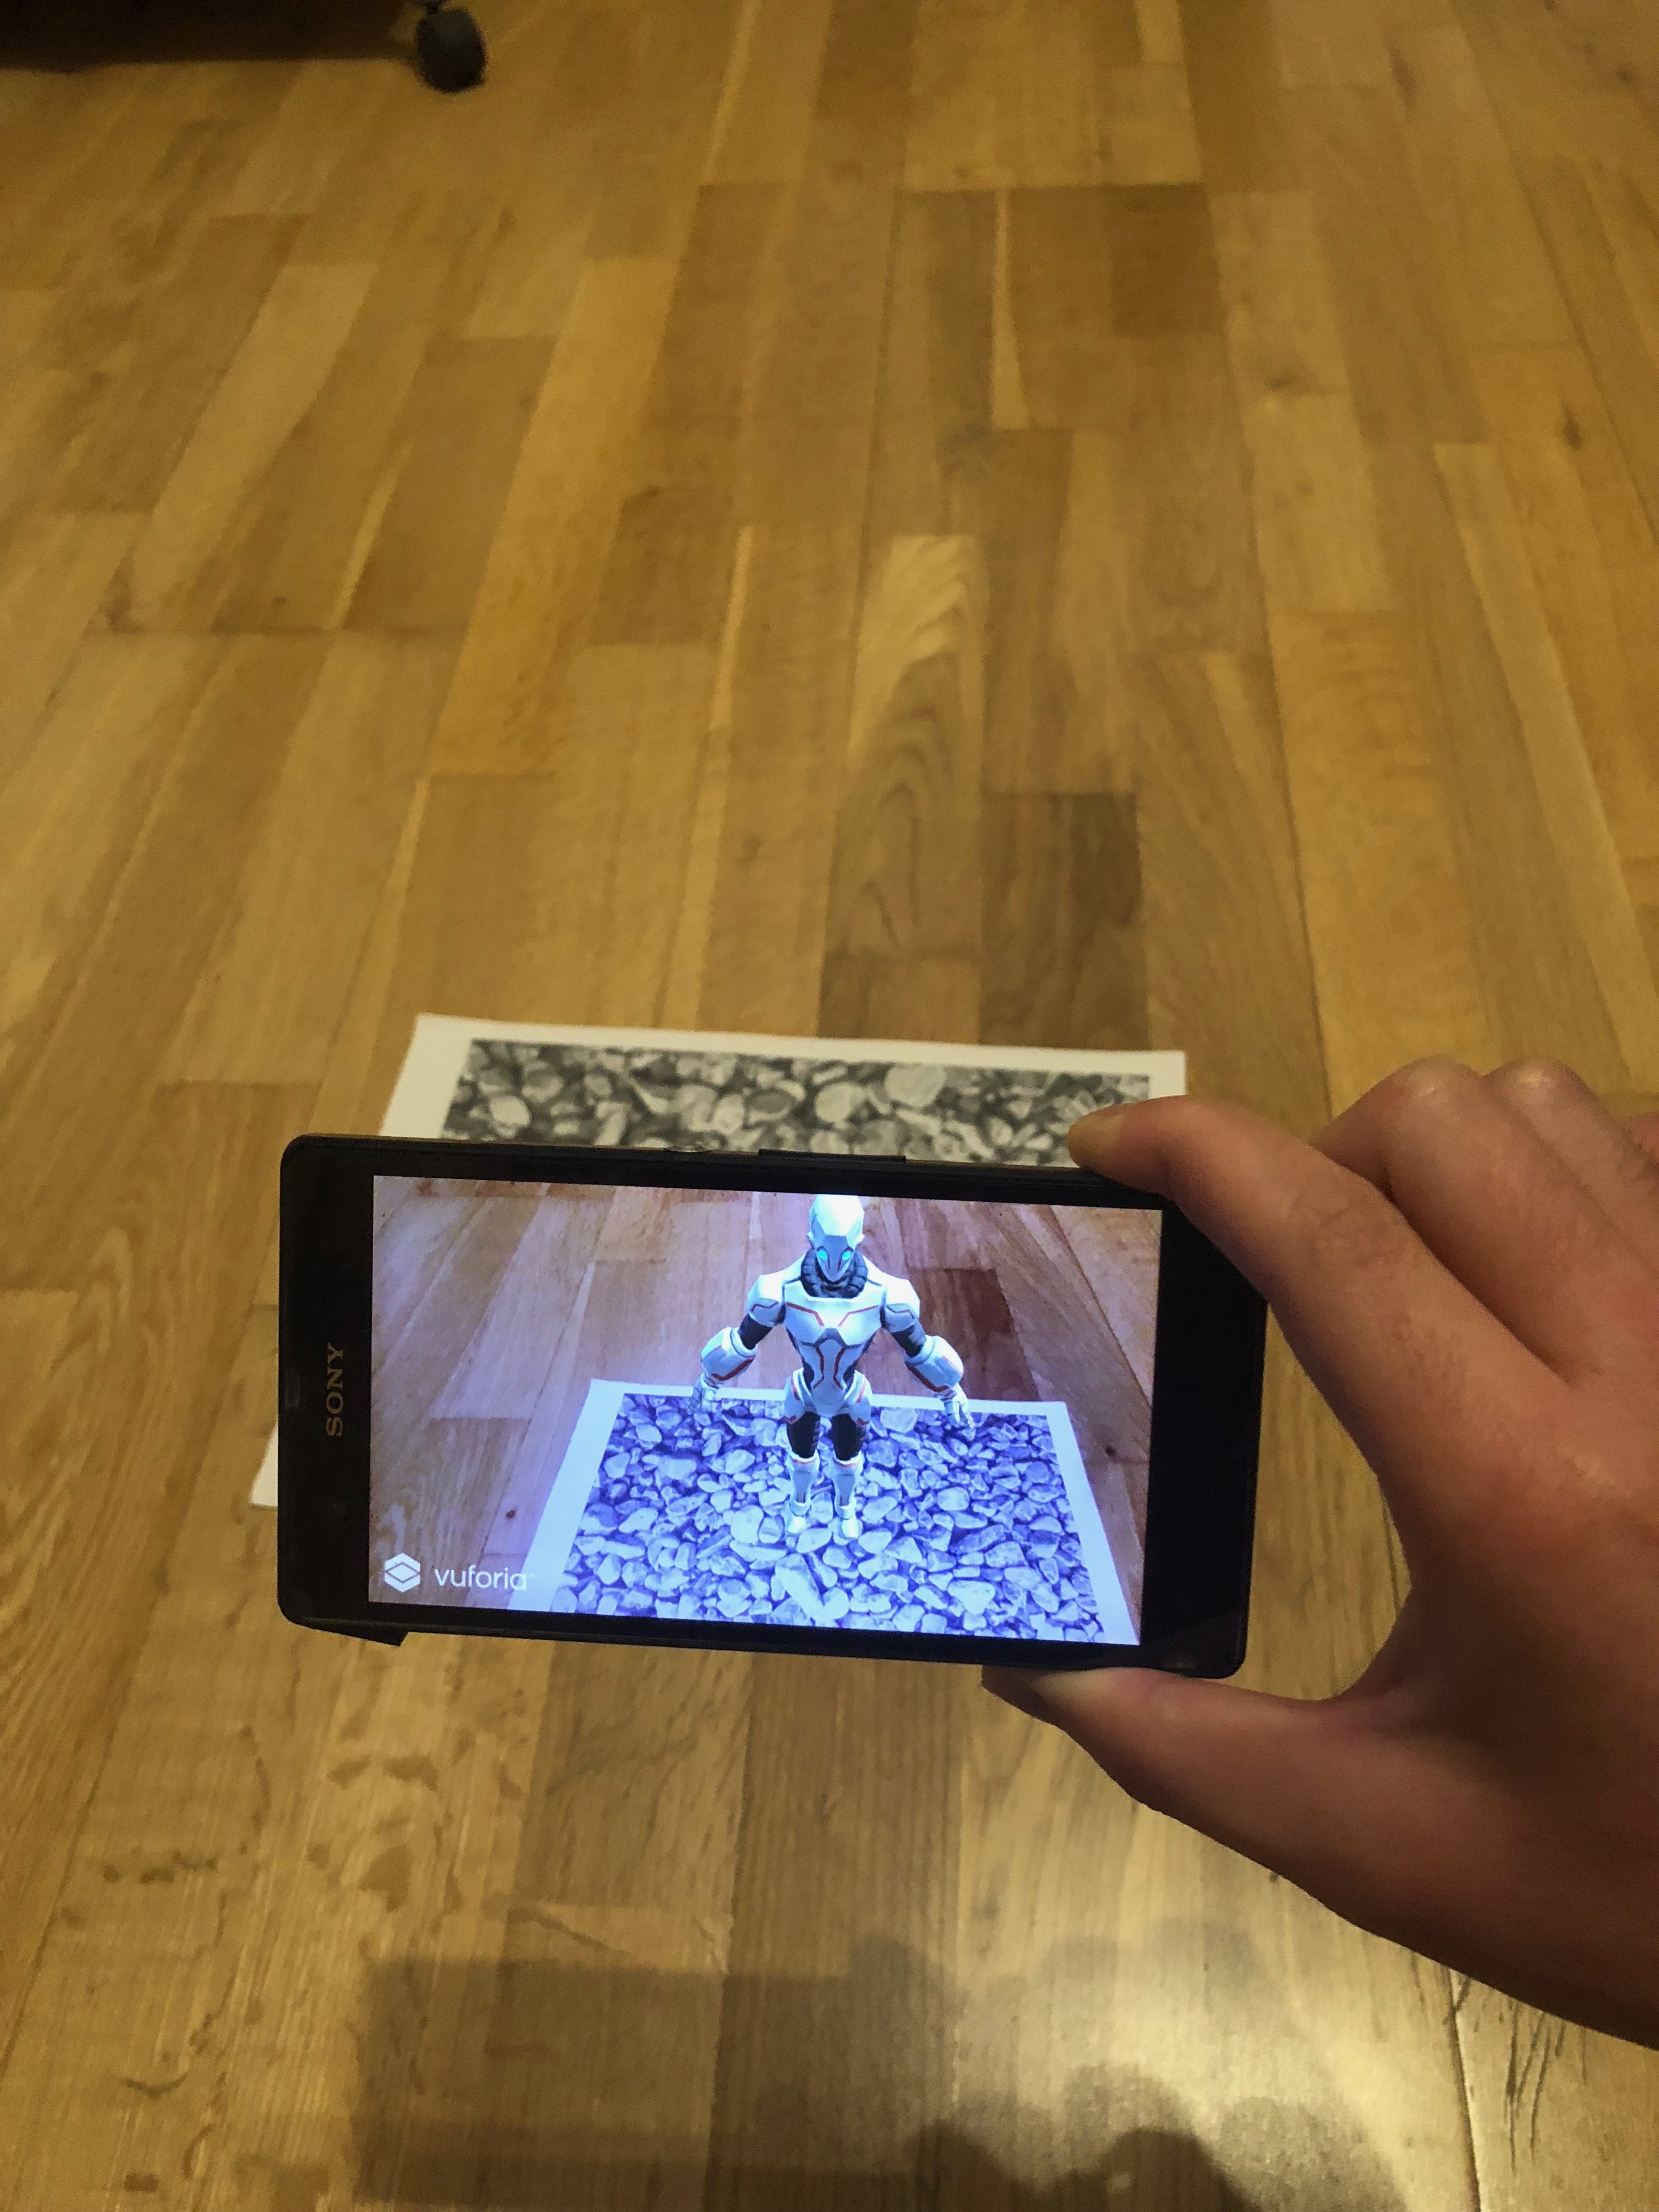

#### 4.4.3 Solutions

* Game Engine: Unity 3D
* IDE: Visual Studio
* Programming Language: C#
* AR Technology: Vuforia
* Version Control: GitHub
* Screen Recorder for Android: DU Recorder

#### 4.4.4 System Architecture Design

Android device 🡪 Vuforia Database🡪 AR Application.

# Chapter 5: Implementation

## 5.1 Sprint 1

|  |  |  |
| --- | --- | --- |
| **Sprint** | **Start Date** | **Finish Date** |
| 1 | 25/01/2018 | 08/02/2018 |

|  |  |  |
| --- | --- | --- |
| **Task Number** | **Details** | **Status** |
| 1 | Evaluate Vuforia Image Target | Complete |
| 2 | Evaluate Vuforia User Defined Targets | Complete |
| 3 | Evaluate Vuforia Ground Plane in Unity | Complete |
| 4 | Evaluate Vuforia Object Scanner | Complete |

The **Vuforia Image Target** works really well overall, however if the camera points away from the AR object, the object is not instantly displayed on the screen when the camera points back to it. The Image target is very easy to use.

The **Vuforia User Defined Targets** technique is very good because it allows the user to place any virtual objects anywhere, the user is not restricted to already defined targets that has been set in advance. The User Defined Targets does not work well in low lighting conditions as it will have difficulty in detecting a target.

The **Vuforia Ground Plane** is a new feature that came as part of Vuforia 7 the newest version at the time of writing this evaluation and is only supported by Unity 2017 3.0. This feature allows users to place virtual objects on horizontal surfaces. Anchor points can also be used to place virtual objects in mid-air. Unlike the Image Target the device camera does not need to detect the marker to show the virtual object.

However there is very limited devices that currently supports Ground Plane. If you don’t have any supported device you can use print out the emulated ground plane marker to test out the ground plane feature.

The **Vuforia Object Scanner** is an android application that allows the user to scan physical object and test how well it will work. It is very easy to setup and import it into Unity 3D.

## 5.2 Sprint 2

|  |  |  |
| --- | --- | --- |
| **Sprint** | **Start Date** | **Finish Date** |
| 2 | 08/02/2018 | 12/04/2018 |

|  |  |  |
| --- | --- | --- |
| **Task Number** | **Details** | **Status** |
| 1 | Vuforia Image Targets Locking Experiments | Finished |
| 2 | Vuforia User Defined Targets Locking Experiments | Finished |
| 3 | Vuforia Ground Plane Locking Experiments | Finished |
| 4 | Vuforia Image Targets Overlapping Experiments | Finished |
| 5 | Vuforia User Defined Targets Overlapping Experiments | Finished |

Due to locking and overlapping metrics in augmented reality not readily available, I purpose these sets of experiments for locking. I will be using Vuforia Image Targets and Vuforia Ground Plane for my sets experiments.

**Vuforia Image Targets, Vuforia User Defined Targets and Vuforia Ground Plane Locking Experiments**

For the sets of experiments for Vuforia Image Target, Vuforia User Defined Targets and Vuforia Ground Plane locking, the experiments will be based on movements such as:

* forward and backwards movements
* left and right movements
* upwards and downwards movement
* Maximum distance before the device camera loses its locking on the AR image target. The following will being measured in metres for the distance.
* Each of these steps will be repeated 6 times.

**Vuforia Image Target, User Defined Targets and Vuforia Ground Plane locking Experiments**

Recommendations will be made at the end of the experiments in regards to which one to use, Vuforia Image targets, Vuforia User Defined Targets or Vuforia Ground Plan

### Vuforia Image Target Experiment:

**Maximum Distance:**

To find the maximum distance for Vuforia Image Target, this experiment was repeated 6 times and during the repetition, 6/6 times when testing the Image Target the maximum distance is about 1.5 metre, any distance longer that it will result in the AR object to become unstable, it will start to disappear and reappear and moving side to side and start jittering. (See recorded experiment video for reference: Vuforia_Max_Distance_Test 1-6)

Vuforia Image Target Maximum Distance

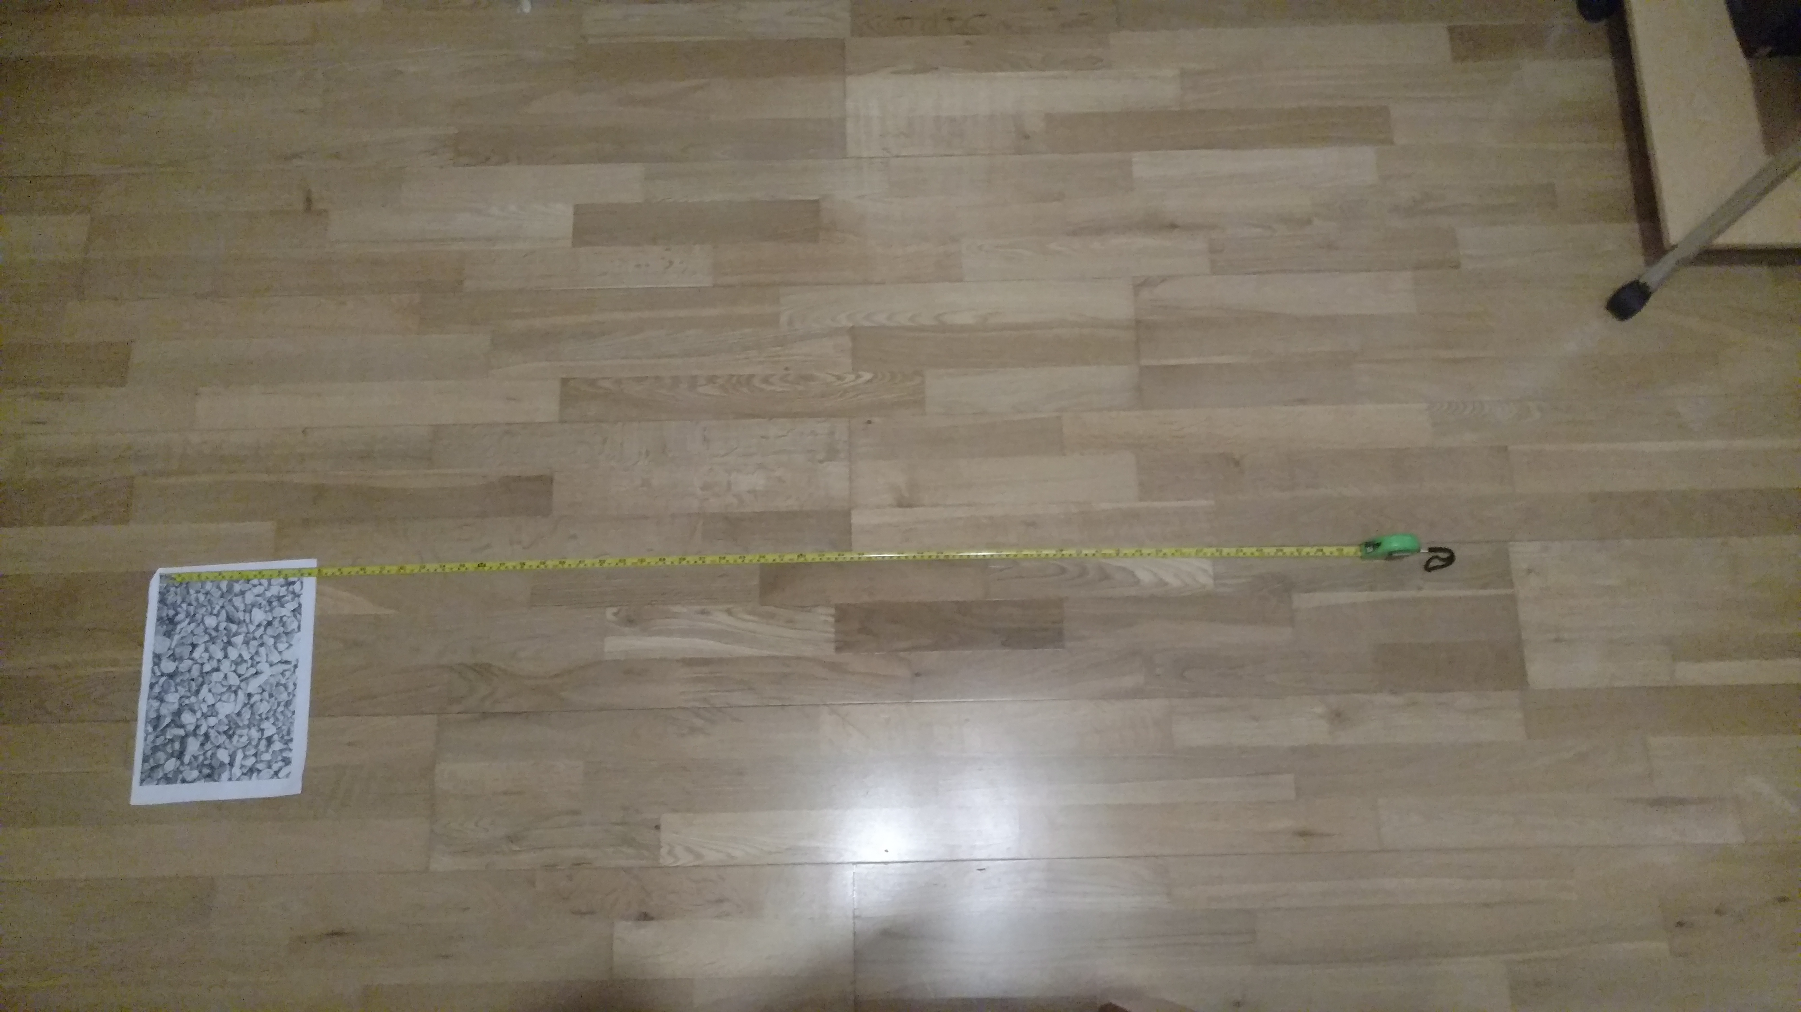

**Upward, Downward, Left and Right movements:**

The experiment was repeated 6 times and during the repetition 6/6 times, if the device is within Maximum Distance of 1.5 metres then the upwards, downwards, left and right movements transition back to the image target is very smooth and quick. The AR object will not become unstable, would not move side to side and also there is no jitters (See recorded experiment video for reference: UpDownLeftRight_withinMaxDistance).

The same experiment was also repeated, but it’s not within the Maximum Distance of 1.5 metres. The experiment was repeated 12 times. The upwards, downwards, left and right movements transition back to image target the AR object will still appear but because it is not within the Maximum Distance, the AR object will be unstable, moving side to side and jitter a lot. During the experiment the target was lost once and it was able to lock onto it again, however when the target was lost once more, it was not possible to lock onto it again (See recorded experiment video for reference: UpDownLeftRight_MaxDistance_Test_1 & UpDownLeftRight_MaxDistance_Test_2)

**Backward movements:**

The backward movements is very good until certain range when it reaches its maximum distance as describes above in “Maximum Distance”.

**Forward movements:**

The forward movements is very good it is still able to detect the image target and the AR object remain stable.

**Image Target Overlapping:**

I had tried to overlap the Image Target 6 times. 6/6 times the camera can still lock and display the AR object even if it still overlaps a bit more than half the image target a very close distance to the image target(See recorded experiment video for reference: Overlapping_ Image_Target). However 6/6 times, if the AR object is lost from a further distance it is very hard to relock and display the AR object when the target image is overlapped(See recorded experiment video for reference: Overlapping _the Target_Image_ from_Further_ Distance)

The Image is not overlapped The Image is overlapped

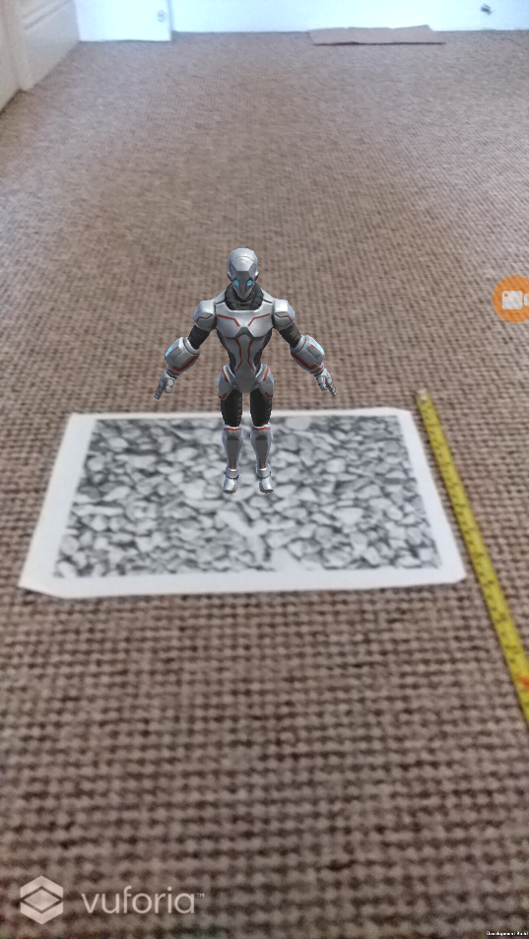 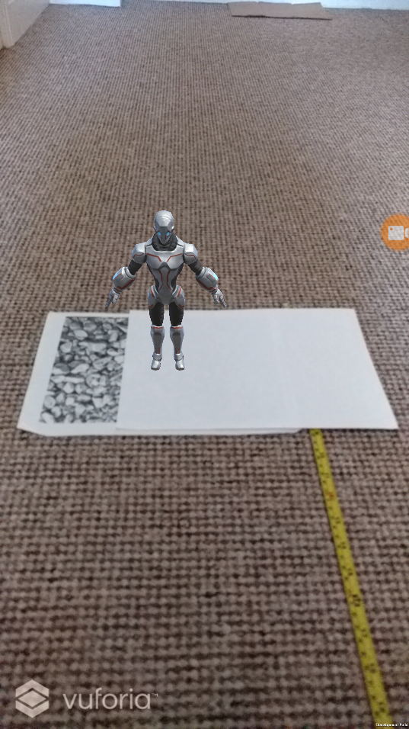

Image Target

AR Object

Paper to Overlap the Image Target

### Vuforia User Defined Targets Experiment:

**Maximum Distance:**

To find the maximum distance for Vuforia User Defined Targets, this experiment was repeated 6 times and during the repetition, 6/6 times when testing the Image Target the maximum distance is about 2.4 metre, any distance longer that it will result in the AR object to become unstable, it will start to disappear and reappear and moving side to side and start jittering. (See recorded experiment video for reference: MaxDistance UDT 1-6)

**Upward, Downward, Left and Right movements:**

The experiment was repeated 6 times and during the repetition 6/6 times, if the device is within Maximum Distance of 2.4 metres then the upwards, downwards, left and right movements transition back to the image target is very smooth and quick. The AR object will not become unstable, would not move side to side and also there is no jitters (See recorded experiment video for reference: UpDownLeftRight_WithinMaxDistance_UDT_Test).

The same experiment was also repeated, but it’s not within the Maximum Distance of 2.4 metres. The experiment was repeated 6 times. The upwards, downwards, left and right movements transition back to image target the AR object will still appear but because it is not within the Maximum Distance, the AR object will be unstable, moving side to side and jitter a lot. The AR object was lost 3 times during the upward movement back to the target, however it can still lock on to the target and the AR object will appear again when the camera field of view is moved away from the target and back to the target again. (See recorded experiment video for reference: UpDownLeftRight_OutSideMaxDistance_UDT_Test).

**Backward movements:**

The backward movements is very good until certain range when it reaches its maximum distance as describes above in “Maximum Distance”.

**Forward movements:**

The forward movements is very good it is still able to detect the image target and the AR object remain stable.

**How many objects can Vuforia User Defined Target can lock onto at the same time?**

6/6 times the Vuforia User Defined Target can only lock onto 4 objects at the same time. (See recorded experiment video for reference: Max_Number_of _Objects_UDT_can _Dispaly).

Quality of the Target for AR Objects to be placed on

High Quality (Green)

Medium Quality (Yellow)

Low Quality (Red)

AR Objects

Targets that the AR Objects will appear on

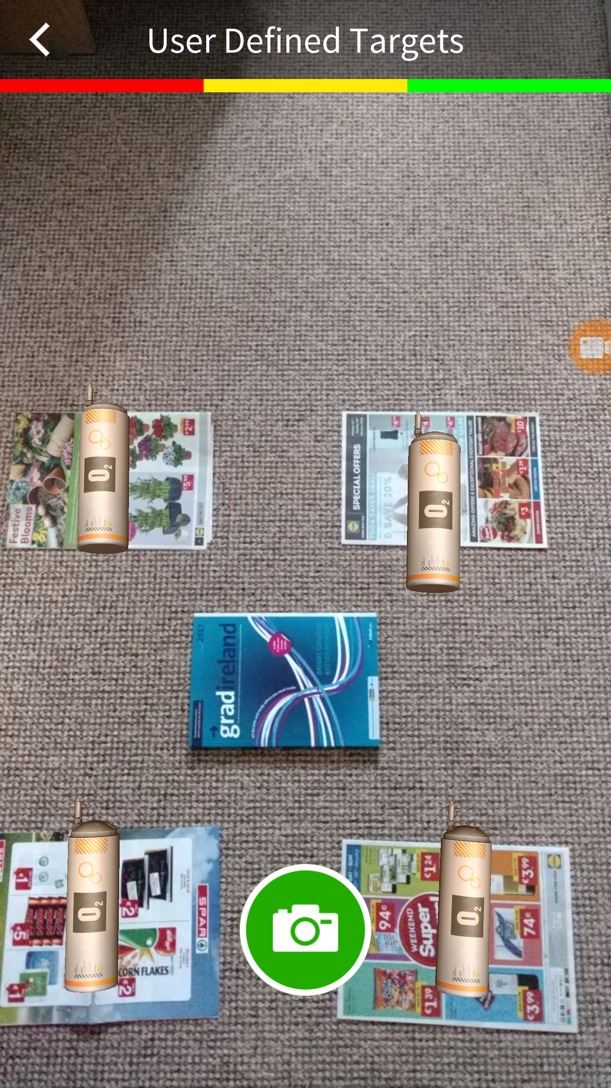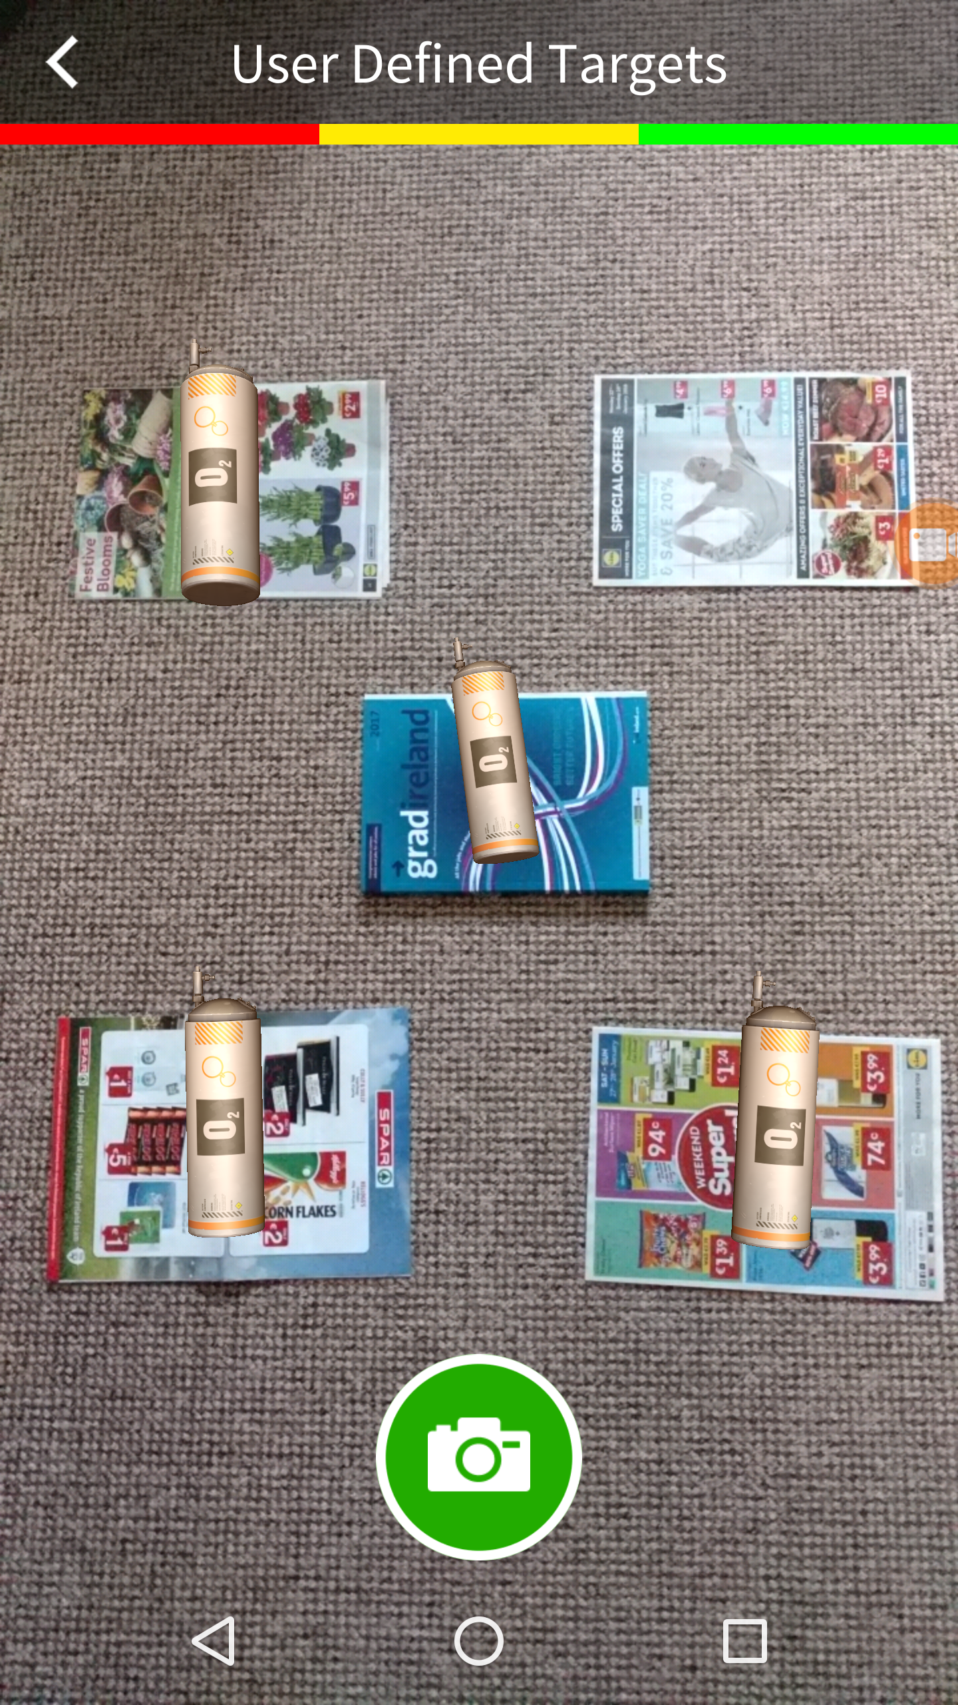

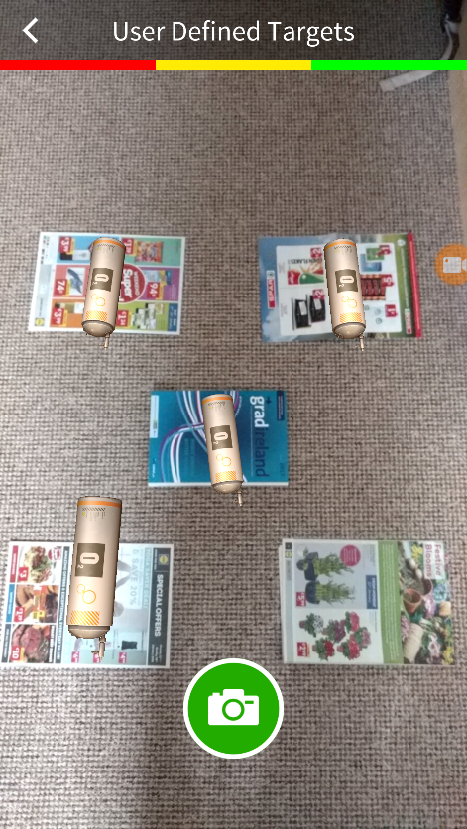

AR Objects

Targets that the AR Objects will appear on

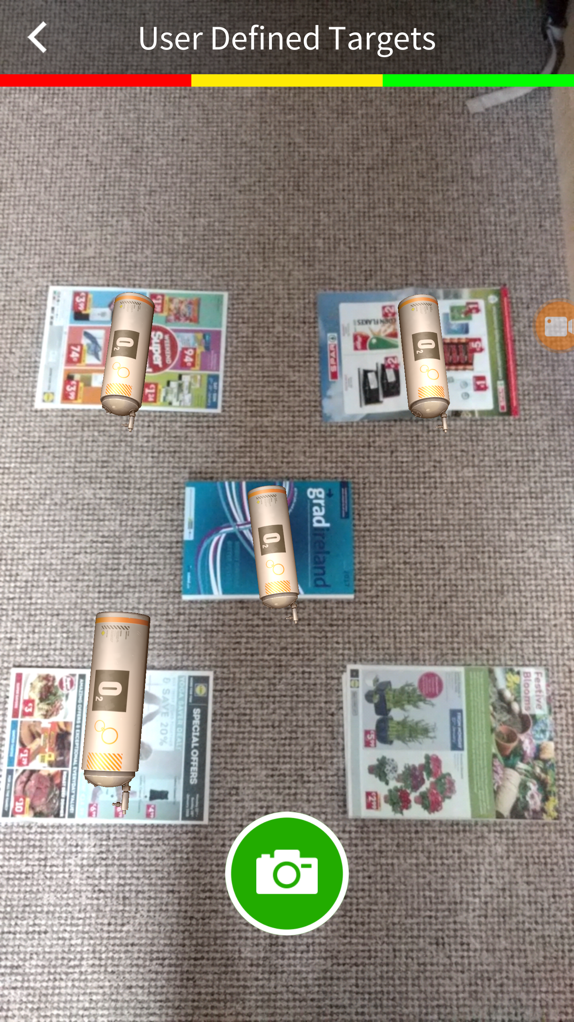

**User Defined Targets Overlapping:**

For This Overlapping Experiment on User Defined Targets, I tested 3 different targets each target I repeated the same steps 6 times to overlap the targets. I used a black background for this experiment as I do not want the User Defined Target to recognise the background as part of the target and display the AR object.

For the first target, I repeated the overlapping 6 times, 6/6 times if I overlap about 70-80 % of the target the AR object will disappear. (See recorded experiment video for reference: Overlapping_User_Defined_Targets_1).

For the second target, I repeated the overlapping 6 times and like the first experiment if I overlap about 70-80% of the target the AR object will disappear. (See recorded experiment video for reference: Overlapping_User_Defined_Targets_2).

For the third target, I repeated the overlapping 6 times and like the 2nd and 3rd experiment it’s more of the same result I got. It’s about 70-80% of the target the AR object will disappear. (See recorded experiment video for reference: Overlapping_User_Defined_Targets_3).

1st Experiment target 2nd Experiment Target

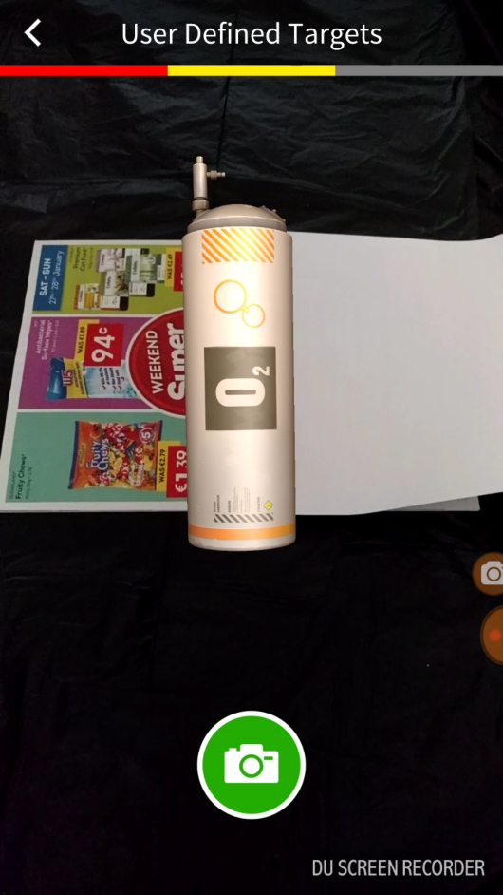

Paper to Overlap the Image Target

AR Objects

Targets that the AR Objects is placed

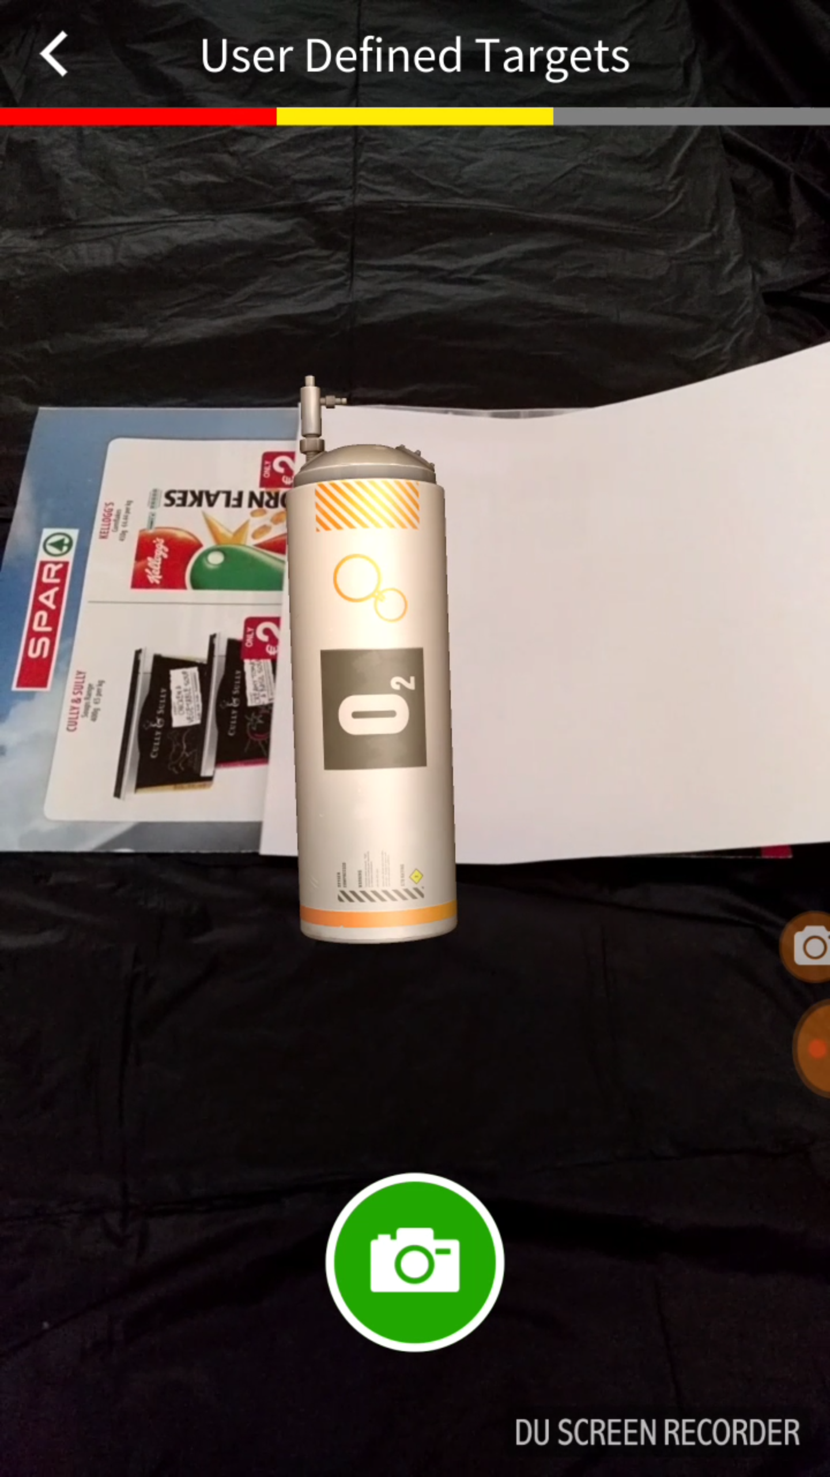

3rd Experiment Target

AR Object

Target that the AR Objects is placed

Paper to Overlap the Image Target

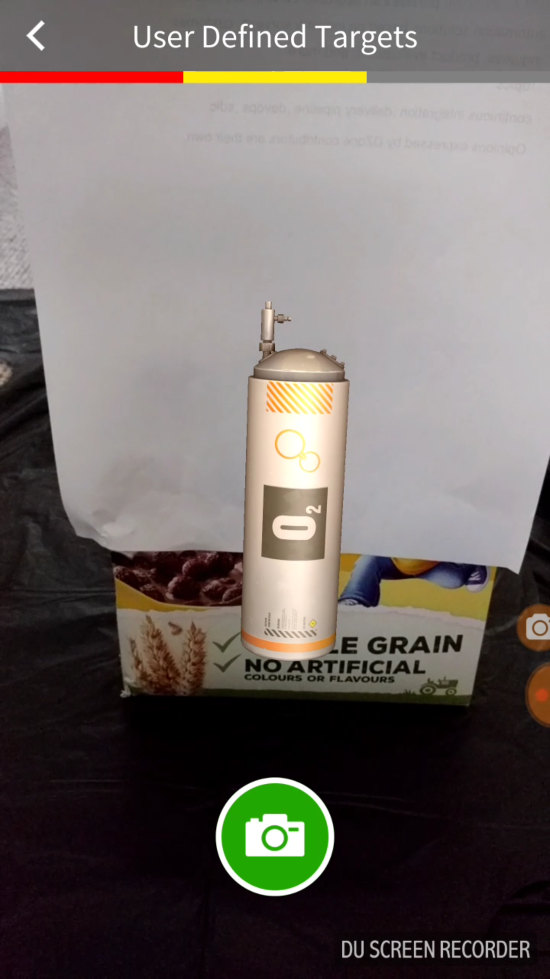

### Vuforia Ground Plane Experiment

The Vuforia Ground Plane is a new feature that was introduced in early 2018, the Android smartphones that can make use of this feature is limited. I had to use an emulated ground plane for this experiment with a webcam. With a compatible Android device the emulated ground plane is not needed.

AR Objects

Emulated ground plane

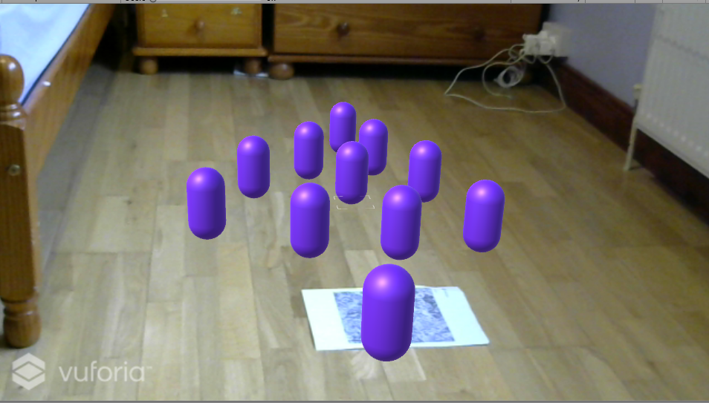

AR Object

Emulated ground plane

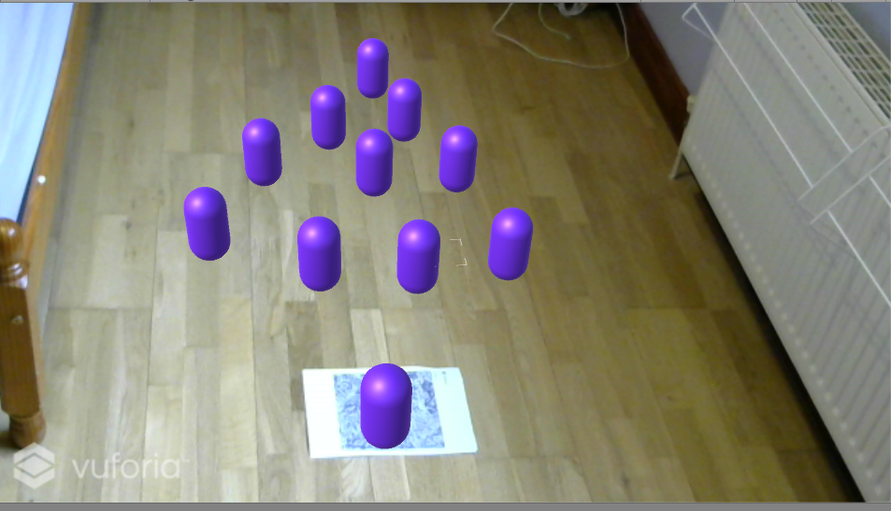

**Upward, Downward, Left and Right movements:**

The experiment was repeated 6 times and during the repetition 6/6 times. The AR objects remains very stable when transitioning from left, right upwards and downwards where the marker less AR objects was placed. However there are times when the ground plane finder suddenly disappears during the experiment then AR objects will not appear, I would need the use the ground plane emulator to activate the plane finder than the AR objects will appear again. (See recorded experiment video for reference: Vuforia Ground Plane 1 and Vuforia Ground Plane 2).

## 5.3 Sprint 3

|  |  |  |
| --- | --- | --- |
| **Sprint** | **Start Date** | **Finish Date** |
| 3 | 12/04/2018 | 2018 |

|  |  |  |
| --- | --- | --- |
| **Task Number** | **Details** | **Status** |
| 1 | Create and Setup Unity Project | Finished |
| 2 | Get Vuforia Development Key for the Unity Project | Finished |
| 3 | Set Up Vuforia AR Platform In Unity | Finished |
| 4 | Set Up Vuforia Ground Plane In Unity | Finished |

Virtual chessboard using Vuforia Ground Plane and putting chess pieces on the chessboard and move the chess piece.

Create a Development Key from your Vuforia Development Portal

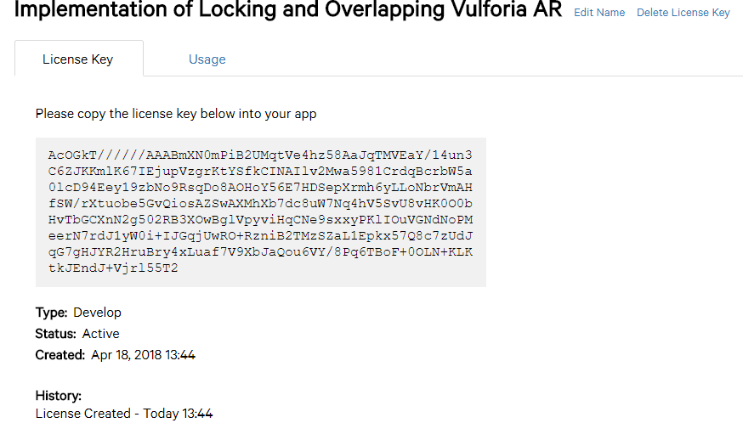

The Development is now active and ready to use

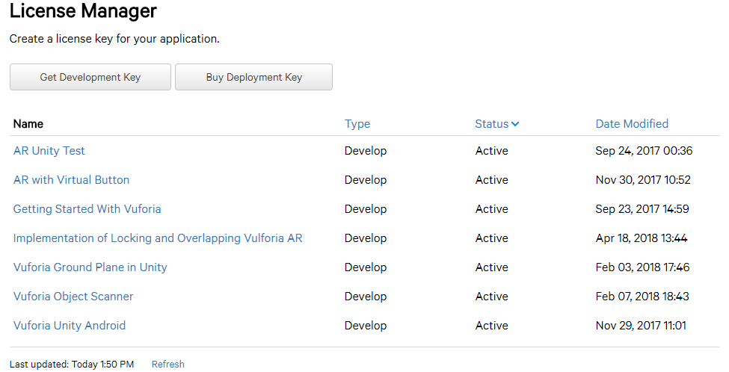

Copy the Development Key into App license key space in VuforiaConfiguration inside Unity

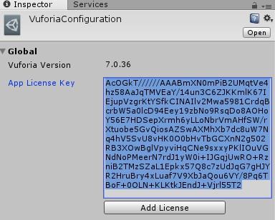

Add Ground Plane Stage, Plane Finder and AR Camera. Delete the Main Camera in the Hierarchy

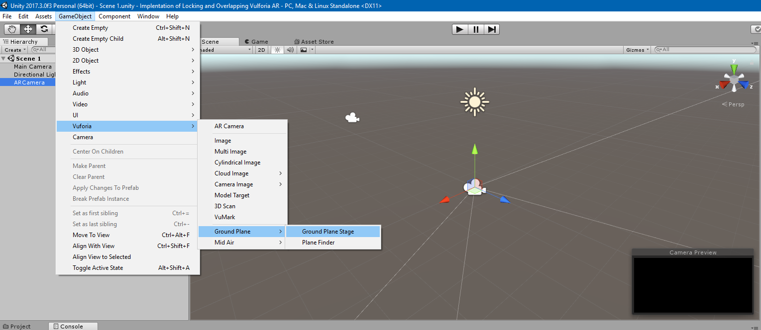

Ground Plane Stage in Unity Scene

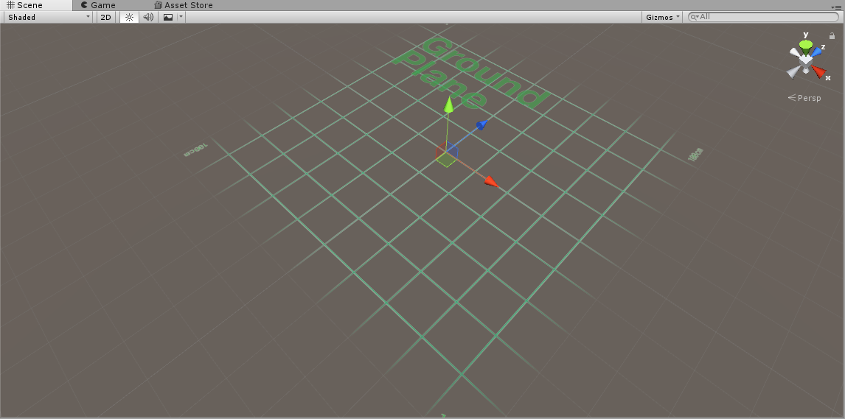

Drag and Drop Ground Plane Stage into Plane Finder – Anchor Stage

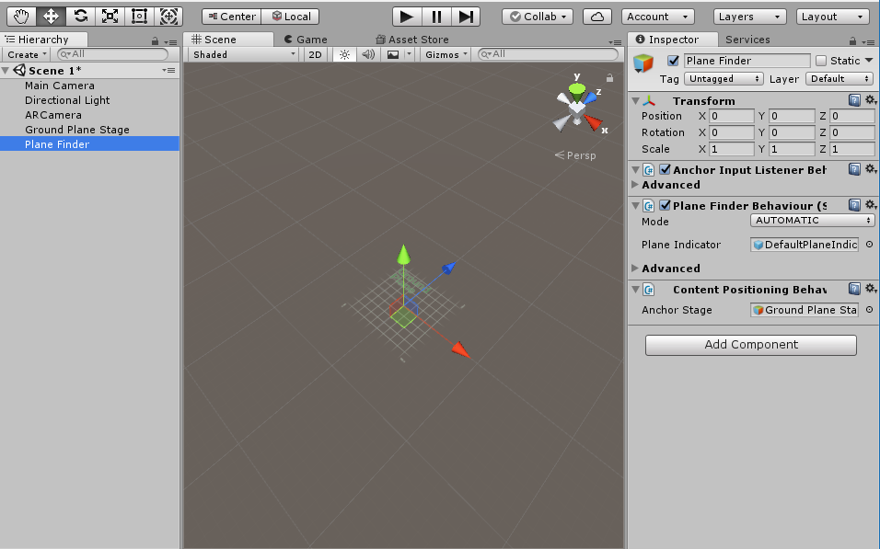

# **References**

Azuma, R. et al., 2001. Recent advances in augmented reality. *IEEE Computer Graphics and Applications,* 21(6), pp. 34-47.

Bell, K., 2017. *Mashable.* [Online]   
Available at: http://mashable.com/2017/09/24/download-this-ikea-place-ar-kit-app/#tFnSXS8eiiq8  
[Accessed 07 12 2017].

Brachmann, S., 2014. *IP Watchdog.* [Online]   
Available at: http://www.ipwatchdog.com/2014/11/26/a-brief-history-of-googles-android-operating-system/id=52285/  
[Accessed 26 11 2017].

Chatila, R. & Laumond, J.-P., 1985. *Position referencing and consistent world modeling for mobile robots.* St. Louis, IEEE.

Clemens, A. & Dieter Schmalstieg, 2011. *Clemend Arth.* [Online]   
Available at: http://www.arth.co.at/data/papers/challenges.pdf  
[Accessed 28 10 2017].

Cushnan, D. & El Habbak, H., 2013. *Developing AR Games for iOS and Android.* Birmingham: Packt Publishing Ltd.

Danny, M., 2013. *Cross Media Masterpiece.* [Online]   
Available at: https://xmediaramblings.wordpress.com/2013/04/08/workshop-3-week-9-hackathon/  
[Accessed 17 10 2017].

Davis , R. C., 2015. *Cuny Academic Works.* [Online]   
Available at: https://academicworks.cuny.edu/cgi/viewcontent.cgi?article=1034&context=jj_pubs  
[Accessed 31 1 2018].

Google, 2017. *ARCore Google.* [Online]   
Available at: https://developers.google.com/ar/discover/  
[Accessed 21 04 2018].

Haines, O., 2016. *Kudan.* [Online]   
Available at: https://www.kudan.eu/kudan-news/an-introduction-to-slam/  
[Accessed 29 10 2017].

Huang , C.-Y., 2016. An Innovative Proposal for Young Students to Learn Computer Science and Technology through Pokemon Go. *2016 International Conference on Computational Science and Computational Intelligence (CSCI),* pp. 246-251.

Ibanez, A. S. & Figueras, J. P., 2013. *UPCommons.* [Online]   
Available at: https://upcommons.upc.edu/bitstream/handle/2099.1/17769/memoria.pdf  
[Accessed 07 12 2017].

Katiyar, A., Kalra, K. & Garg, C., 2015. Marker Based Augmented Reality. *Advances in Computer Science and Information Technology,* 2(5), pp. 441-445.

Kesim, M. & Ozarslan, Y., 2012. Augmented Reality in Education: Current Technologies and the Potential for Education. Volume 47, pp. 297-302.

Kim, S. L. et al., 2014. Using Unity 3D to Facilitate Mobile Augmented. *Using Unity 3D to Facilitate Mobile Augmented.*

Kipper, G. & Rampolla, J., 2012. *Augmented Reality : An Emerging Technologies Guide to AR.* First Edition ed. Waltham: Elsevier Science.

Kudan, n.d. *Kudan.* [Online]   
Available at: https://www.kudan.eu/about/  
[Accessed 11 10 2017].

Kudan, n.d. *Kudan.* [Online]   
Available at: https://www.kudan.eu/kudan-sdk-features/  
[Accessed 11 10 2017].

Lee, D., 2017. *The Verge.* [Online]   
Available at: https://www.theverge.com/2017/9/20/16339006/apple-ios-11-arkit-ikea-place-ar-app  
[Accessed 07 12 2017].

Loeb, W., 2013. *Forbes.* [Online]   
Available at: https://www.forbes.com/sites/walterloeb/2012/12/05/ikea-is-a-world-wide-wonder/#575907ef27b9  
[Accessed 7 12 2017].

Matthew, M., 2017. *linkedin.* [Online]   
Available at: https://www.linkedin.com/pulse/introduction-augmented-reality-ar-moncy-mathew/  
[Accessed 10 04 2017].

McGarry, C., 2018. *tom's guide.* [Online]   
Available at: https://www.tomsguide.com/us/apple-arkit-faq,review-4636.html  
[Accessed 2018 04 21].

Mine, M. R., Van Baar, J., Grundhöfer, A. & Yang, B., 2012. *ResearchGate.* [Online]   
Available at: https://www.researchgate.net/publication/235961176_Projection-Based_Augmented_Reality_in_Disney_Theme_Parks  
[Accessed 21 03 2018].

Mix, 2017. *The Next Web.* [Online]   
Available at: https://thenextweb.com/gaming/2017/02/14/pokemon-go-monster-trading-battles/#.tnw_vWCNZ9K3  
[Accessed 28 09 2017].

Orf, D., 2016. *Gizmodo.* [Online]   
Available at: https://gizmodo.com/a-brief-history-of-ios-1780790760  
[Accessed 26 11 2017].

Orland, K., 2012. *Ars Technica.* [Online]   
Available at: https://arstechnica.com/gaming/2012/03/virtual-reality-that-doesnt-suck-my-time-inside-half-life-2/  
[Accessed 28 09 2017].

Ortiz-Catalan, M. et al., 2014. *Frontier in Neuroscience.* [Online]   
Available at: https://www.frontiersin.org/articles/10.3389/fnins.2014.00024/full  
[Accessed 21 03 2018].

Peng, F. & Jing , Z., 2017. A Mobile Augmented Reality System for Exhibition Hall Based on Vuforia. *2017 2nd International Conference on Image, Vision and Computing (ICIVC),* pp. 1049-1052.

Reality Technologies, 2016. *Reality Technologies.* [Online]   
Available at: http://www.realitytechnologies.com/augmented-reality  
[Accessed 21 03 2018].

Reitmayr, G. et al., 2010. *Simultaneous Localization and Mapping for Augmented Reality.* Gwangju, South Korea, IEEE.

Shore, J., 2012. *MashableUK.* [Online]   
Available at: http://mashable.com/2012/09/24/augmented-reality/#WPd_bY2ZKsqx  
[Accessed 04 10 2017].

Taketomi, T., Uchiyama, H. & Ikeda, S., 2017. *Visual SLAM algorithms: a survey from,* s.l.: Springer Berlin Heidelberg.

Ufkes, A. & Fiala, M., 2013. *A Markerless Augmented Reality System for Mobile Devices.* Regina, SK, Canada, IEEE.

van Krevelen, D. & Poelman, R., 2010. A Survey of Augmented Reality Technologies, Applications and Limitations. *The International Journal of Virtual Reality,* pp. 1-20.

Vuforia , 2012. *Vuforia.* [Online]   
Available at: https://library.vuforia.com/articles/Training/User-Defined-Targets-Guide  
[Accessed 11 12 2017].

Vuforia , 2015. *Vuforia Developer Library.* [Online]   
Available at: https://library.vuforia.com/articles/Training/Image-Target-Guide  
[Accessed 14 02 2018].

Vuforia, 2018. *Vuforia Developer Libary.* [Online]   
Available at: https://library.vuforia.com/features/environments/ground-plane-guide.html  
[Accessed 08 02 2018].

Zsila, Á. &. G. O. &. B. B. &. T.-K. I. &. K. O. &. G. M. &. D. Z., 2017. *An empirical study on the motivations underlying augmented reality games: The case of Pokémon Go during and after Pokémon fever.* s.l.:s.n.